**TetraCity**

A Final Project for CMSC 197: Game Development and Design

Cantiller, Sophia Feona

Enorio, Kyle

Sardañas, Reah Mae

Valente, Nhilbert Jay

Submitted to:

Franz Angelo U. Apoyon

May 2024

## **Introduction**

Before smartphones transformed into essential tools for daily life, entertainment options were straightforward, particularly in the era of basic cellular phones. The rise in cellular phone usage during the 1990s marked the birth of mobile gaming, introducing a new medium of entertainment to a wide audience. Iconic games like "Snake," which debuted on Nokia devices, caught the interest of millions and laid the groundwork for mobile gaming.

Inspired by this history, our Unity project aims to fuse the nostalgic feel of classic games like "City Bloxx," "Tetris," and "Tricky Towers" into a modern gaming experience. This project seeks to recapture the simplicity and addictive nature of these classics while introducing modernized gameplay elements anchored in today's technology. The game shall offer a combination of building mechanics, puzzle-solving, and real-time physics, offering players a fresh challenge that is both nostalgic and distinctly contemporary.

## **Project Overview**

**Game Type:** Strategy and Puzzle

**Platform:** Windows (Desktop)

**Theme:** Urban construction and city building

**Game Mode:** Single Player

**Objective:**

Players aim to construct towering and stable structures by strategically placing Tetris-like blocks within a city-building simulation environment, timing their placement with precision.

**Description:**

TetraCity is a strategy and puzzle game inspired by the building elements of "City Bloxx," the block manipulation of "Tetris," and the physics challenges of "Tricky Towers." The gameplay is centered around the 'Build a City' mode where players must construct high-rise buildings by placing various shaped blocks with care and precision. Each completed building is then placed on a single block grid that contributes to the development of a city.

Real-time physics are integrated into the gameplay, introducing variables that can sway, topple, or strengthen structures depending on how blocks are aligned. TetraCity offers a straightforward yet challenging experience, ideal for those who enjoy strategy games and city-building simulations.

## **Game Details**

### **Gameplay Elements**

### The game is set in an urban atmosphere, with tall buildings as distinct features in the background to emphasize the theme of stacking buildings. The view of the player is similar to a classic “Tetris” game where the camera primarily faces forward as the player continually stack incoming blocks. The blocks are also urban-themed.

Moreover, 3D rigid body physics affect how the blocks are stacked. The blocks fall from above, and the player can also choose to reserve the current block if it is unfavorable and proceed with the next block in line. The player has to plan carefully how quickly or delicate they would want to stack a block due to the presence of physics, which may cause the stacks the player currently has to sway and fall over before they reach the objective of the current level. The blocks come in classic “Tetris” block shapes, and aligned puzzle shapes contribute to the strengthening of the structures.

### **Gameplay Loop**

### The core gameplay loop involves the player continuously stacking blocks to construct high-rise buildings. The player must be careful with every move, choosing the right side of the Tetris-like shaped building blocks to avoid destabilizing their structures. As the game progresses, the back-and-forth movement of the claw with the unreleased blocks at the top speeds up, challenging the player's strategic thinking, timing, and dexterity.

### **Win Condition/End Goal**

The end game of TetraCity is to construct a tall and sturdy building to accommodate more people, without causing the structure to collapse, as quickly as possible. Each completed building contributes to the city's development, and finishing the construction of all the buildings marks the completion of that area.

### **Game Control**

### The game TetraCity employs a straightforward set of controls to enhance user interaction and gameplay efficiency. These controls are described as follows:

***Drop Block***

Press **SPACEBAR** or click the **LEFT MOUSE BUTTON** to drop the block from the claw holding it.

***Save & Swap Block***

Press **Q** on the keyboard to save the currently displayed block for later use. If a block is already saved, pressing Q again will swap the current block with the saved block.

***Rotate Block***

Press **E** on the keyboard or click the **RIGHT MOUSE BUTTON** to rotate the current block clockwise.

### **Scoring System**

### Scores in TetraCity are based on the height and stability of the constructed buildings, as well as the speed and efficiency of block placement. The more stable and higher the building is constructed, the more population it can hold, resulting in a higher score. Higher scores unlock bonus rewards and contribute to the player's overall progress.

### **Player Decisions**

### Player decisions in TetraCity primarily revolve around block piece alignment, placement, and timing. Choosing the correct puzzle side and optimal placement for each block to maximize stability and minimize the risk of collapse is crucial for success. Additionally, players may encounter branching paths in later levels, where they must decide between prioritizing speed, accuracy, or precision to overcome increasingly challenging obstacles.

## **Technical Specifications**

The game featured low-poly 3D graphics to meet the minimum PC requirements for the majority of possible players. No multiplayer gamemode was added, showcasing only a single player experience. The platform of choice was Windows. Integration of sound effects and background music was also implemented to complement the game. The game also applied the use of 3D rigid body physics to simulate collisions. Assets that were used, which included the 3D objects, backgrounds, and sound effects, were primarily sourced from the Unity store. The game is featured on a 9:16 aspect ratio, similar to those of mobile games.

### 

### **Assets**

We utilized building assets sourced from a free pack available on the Unity Asset Store, specifically the[***Free Low Poly Simple Urban City 3D Asset Pack by DraftPunk Studio*s**](https://assetstore.unity.com/packages/3d/environments/urban/free-low-poly-simple-urban-city-3d-asset-pack-239474). However, since this package solely comprised individual buildings and did not include the classic Tetris-shaped blocks that we needed – namely, the O-block, I-block, S-block, Z-block, L-block, J-block, and T-block – we undertook the task of customizing the available building assets. This involved creating custom prefabs to accurately emulate these essential shapes for our game.

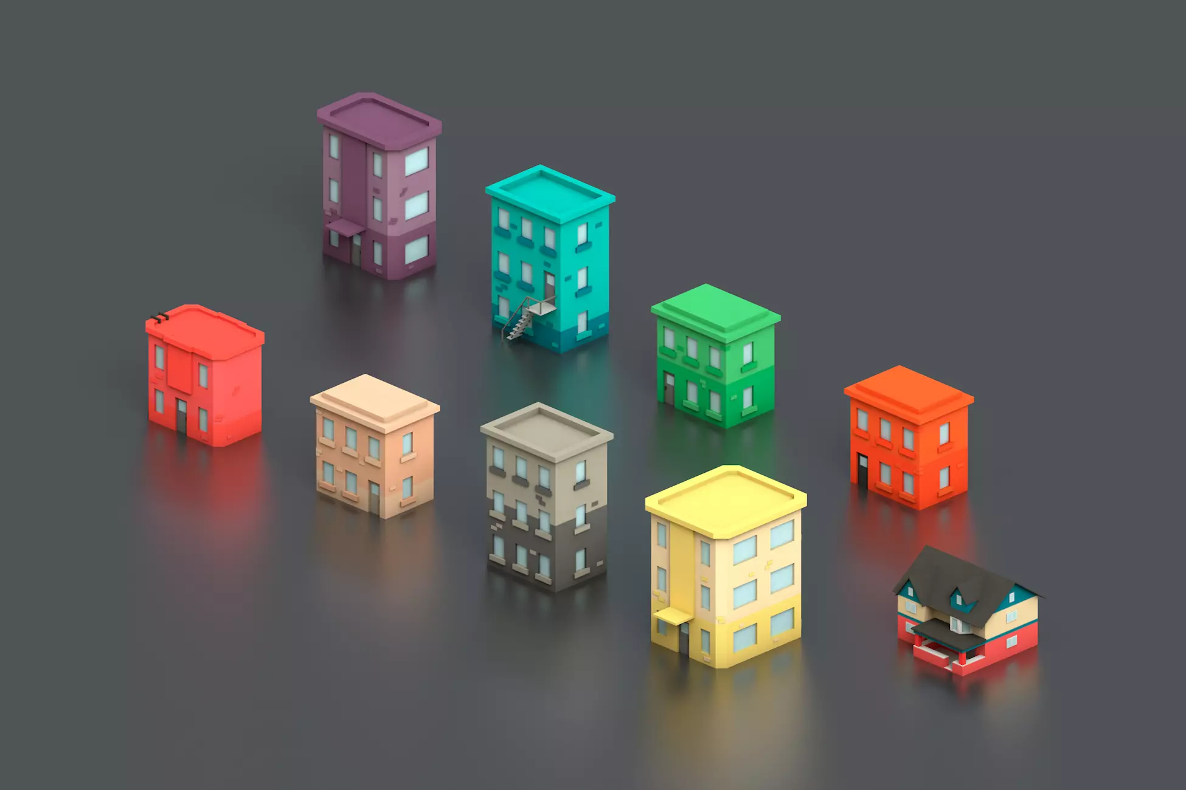

*Image 1: Default shaped colored blocks by DraftPunk Studios*

Each level features differently-colored blocks that are taken from the aforementioned package.

*Image 2: Tetris Shapes*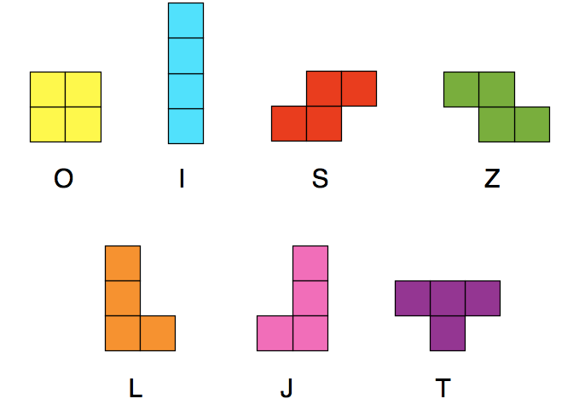

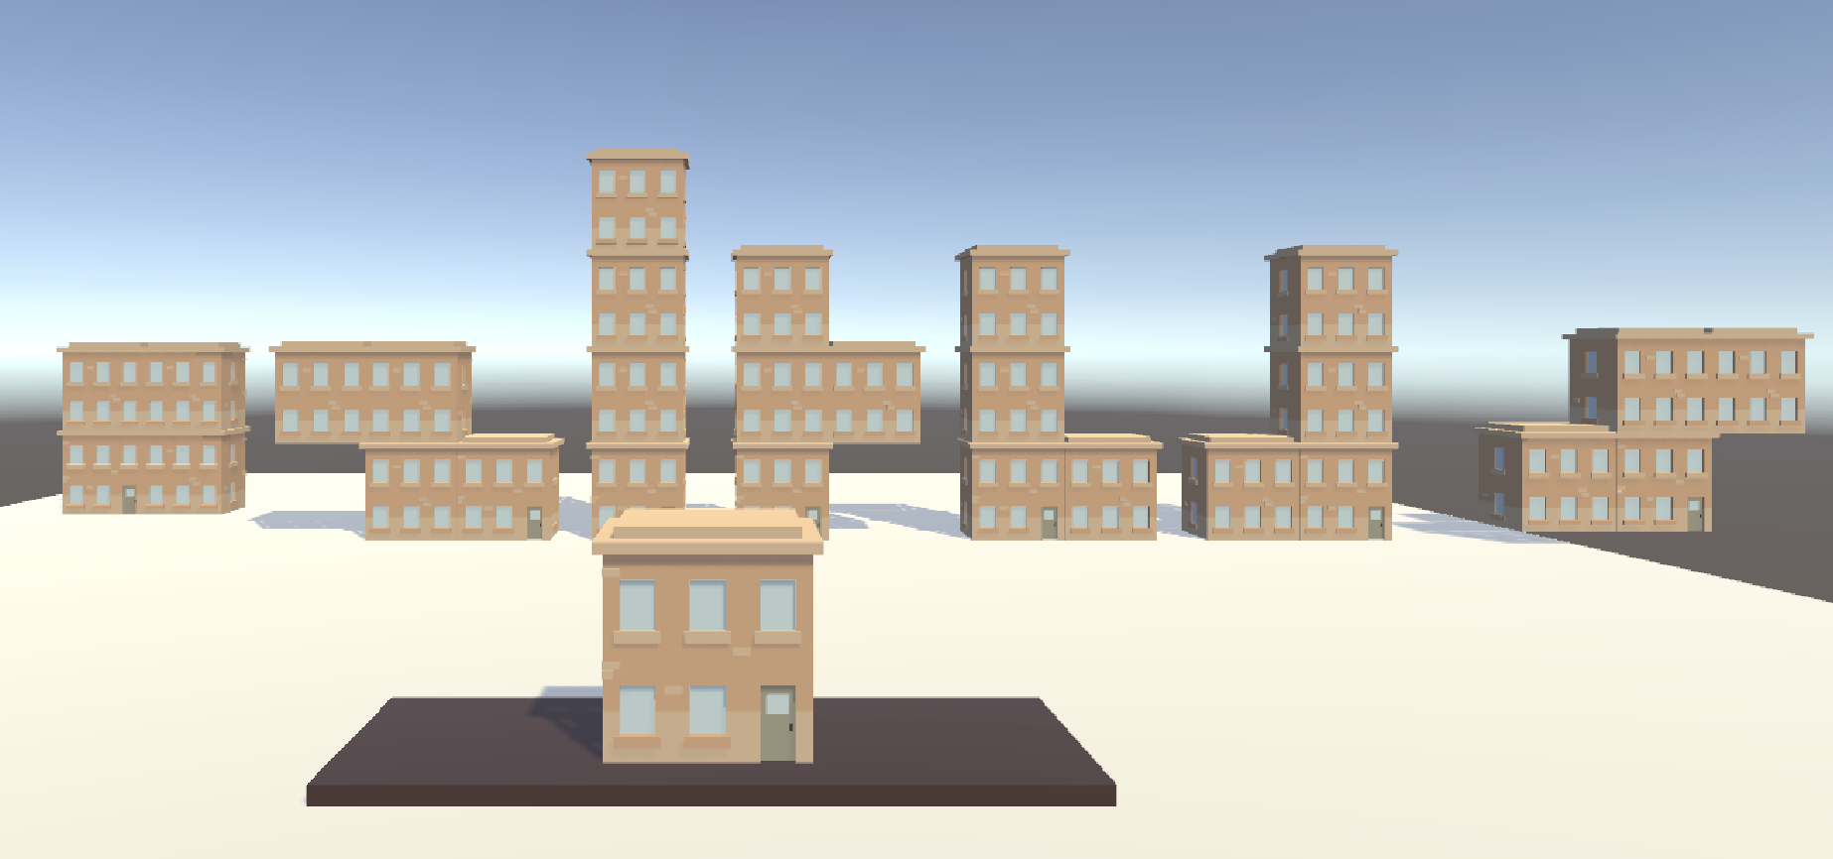

*Image 3: Customized Tetris-shaped Building Blocks*

In addition, we've utilized a rendered claw sprite model created by hnl714 for our claw that holds the unreleased blocks.

*Image 4: Claw by* ***[hnl714](https://sketchfab.com/hnl714)***[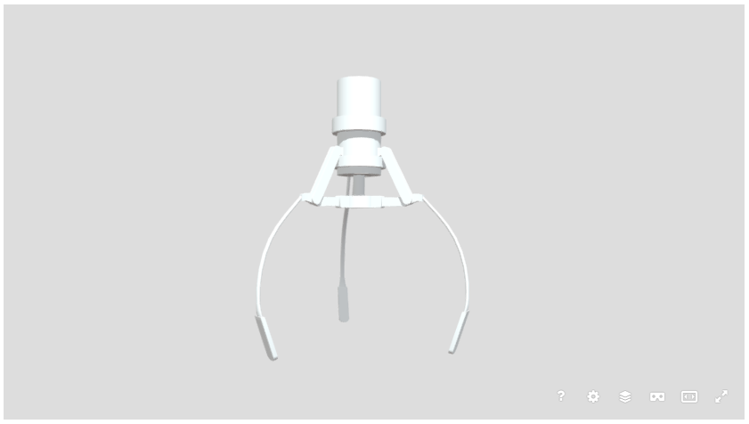](https://sketchfab.com/hnl714)

Furthermore, we've incorporated several 2D assets from the free package "2D Casual UI HD" by MiMU Studio for the buttons and other UI functionalities.

*Image 5: Other utilized UI assets by MiMU STUDIO*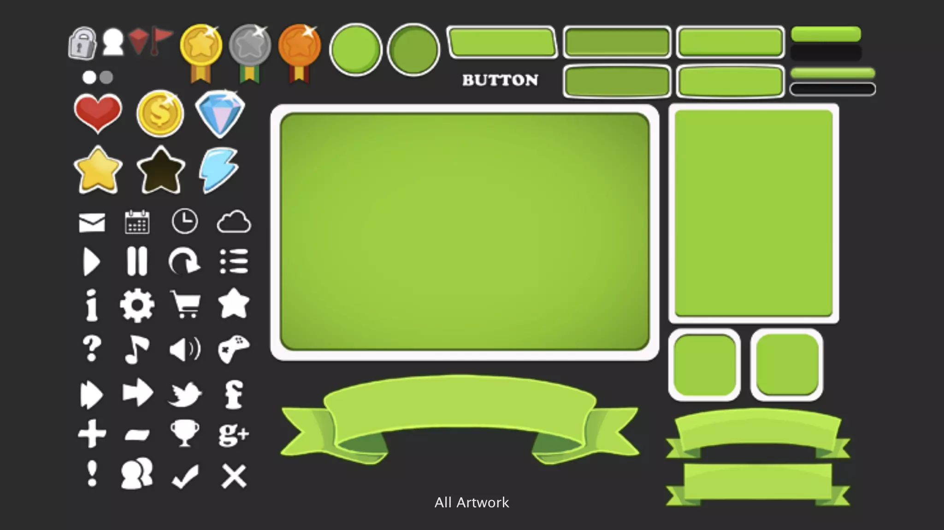

## **User Interface**

This section provides an overview of the different user interfaces (UIs) present in the game. Do note that these designs are subject to change and may be updated over time.

### **Title Screen**

The title screen features a simple animation loop in the background. It includes a single button labeled “Play,” which redirects the user to the Levels Screen upon being clicked.

*Image 6: Title Screen*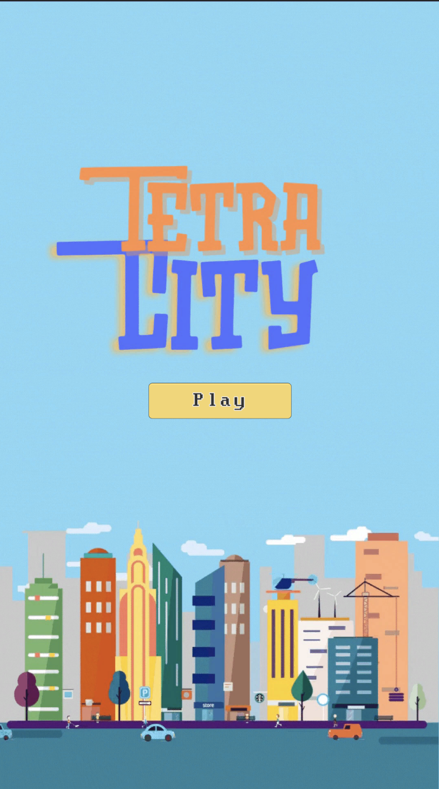

### **Levels Screen**

The game contains three levels, which are shown on the Level Screen after the “Play” button is clicked. The background also features a looped animation to make the user interaction more engaging. The screen also features a “Back” button, which the user can use anytime they want to go back to the Title Screen.

*Image 7: Levels Screen*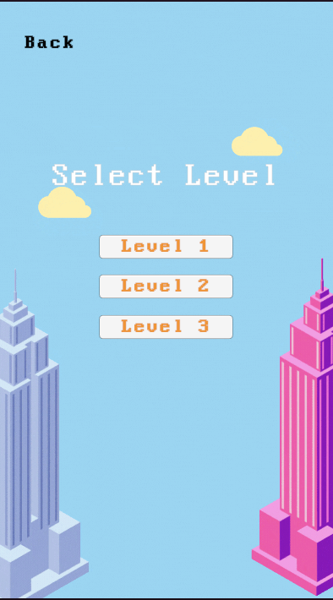

### 

### **Sublevels**

The game comprises main levels, each offering a set of sublevels to challenge the player. Here’s a detailed breakdown of what to expect in each level:

#### **Level 1**

Level 1 features three sublevels initially represented by question mark icons. When the user clicks on any of these question marks, they will be redirected to the game itself.

*Image 8: Level 1*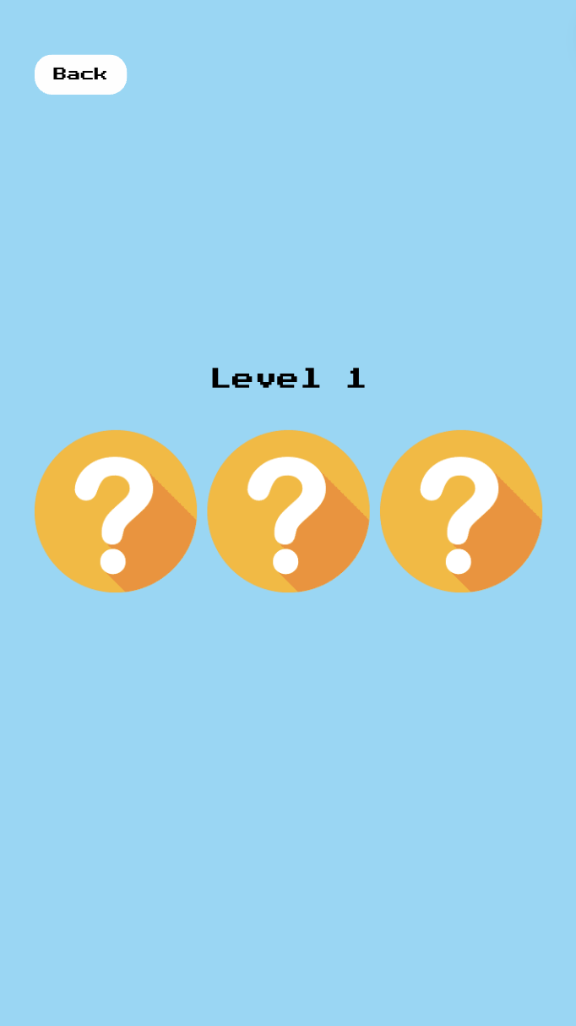

#### **Level 2**

Level 2 features four sublevels that are shown as question mark icons in a 2x2 grid. Once the user clicks on any of these Question Marks, they will be redirected to the game itself.

*Image 9: Level 2*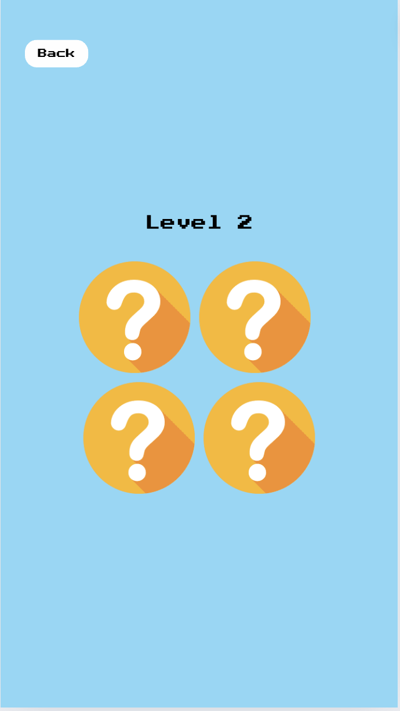

#### **Level 3**

Level 3 features four sublevels that are shown as question mark icons in a 3x3 grid. Once the user clicks on any of these Question Marks, they will be redirected to the game itself

*Image 10: Level 3*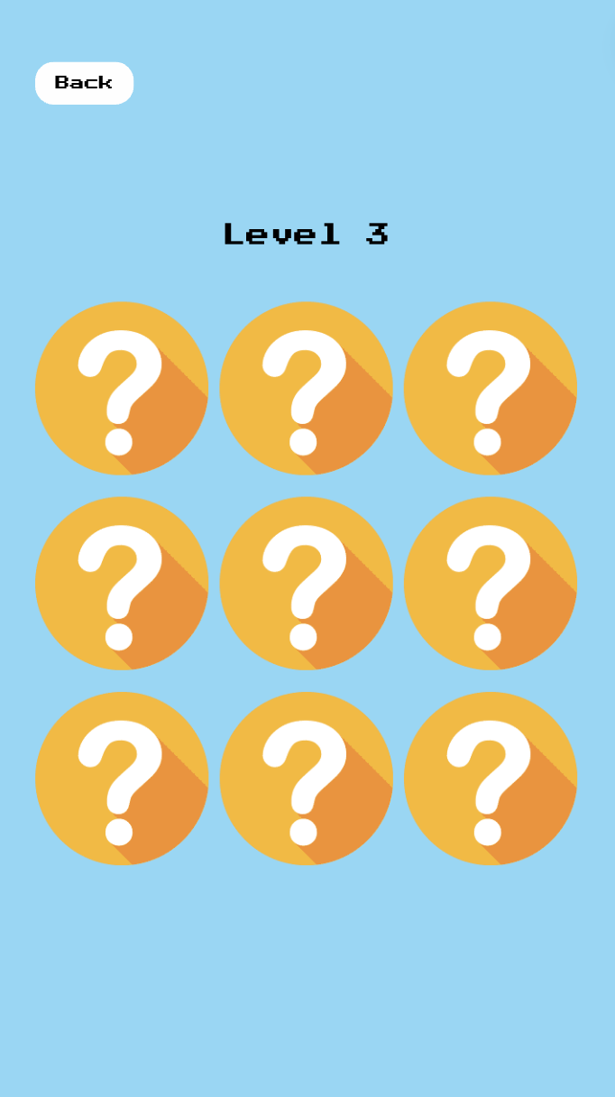

Upon completing a sublevel, the question mark icon will transform into a star. Clicking on the star allows the user to review their work for that sublevel.

*Image 11: Reviewing sublevel previous work*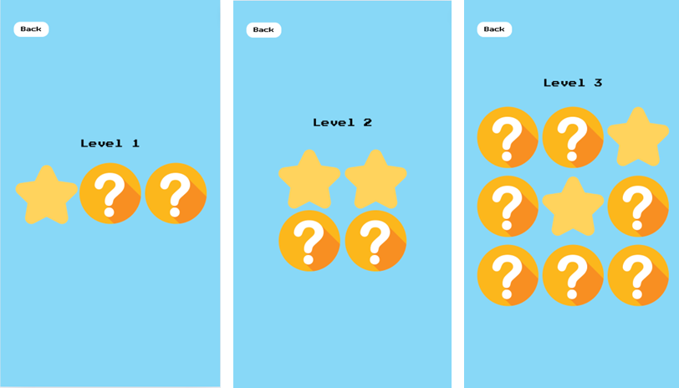

### **Restart Screen**

The user then has an option to restart or go back to the main menu (title screen) after the game is over.

*Image 12: Restart Screen*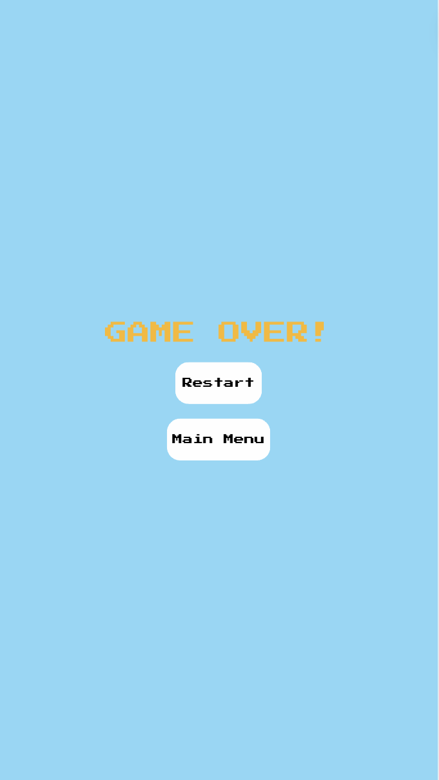

## **Game Logic**

The logic of TetraCity revolves around the game’s core mechanics of stacking blocks to construct stable buildings, similar to ‘Tetris’ but with the added element of real-time physics that affects the stability and height of the buildings within the game. Below is a detailed breakdown of the game logic:

### **Initialization**

1. **Game Start:** When the player starts a game, the initial environment is loaded, including the background, block spawning system, and user interface elements.
2. **Level Setup:** The chosen level and sublevel determine the initial difficulty and forms of the random spawning blocks, setting the stage for challenges ahead.

### **Block Mechanics**

1. **Block Spawning:** Blocks appear at the top of the screen, one at a time, with a preview of the saved, current, and next block shown at the bottom.
2. **Block Control:** The current block held by the claw above moves left and right with speed gradually increasing as the game progresses.Additionally, the player controls the rotation of the current block clockwise with the E key or right mouse button.
3. **Block Dropping:** Pressing the spacebar or clicking the left mouse button drops the block from the claw. Players can also press Q to save a block for later use, swapping it out if another block is already saved.
4. **Physics Application**: As blocks fall and collide with existing structures, real-time physics determine their final resting position, potentially causing shifts or collapses.

### **Building Mechanics**

1. **Placement Strategy:** Players must strategically place each block to maintain stability. Aligning blocks correctly can make the structure structure, while placing the blocks poorly can lead to imbalance and the building may collapse.
2. **Height and Stability:** The game's scoring system rewards higher and more stable buildings. The physics application in the game ensures that as buildings get taller, they easily become more unstable and lead to collapse.

### **Scoring and Progression**

1. **Scoring:** Points are awarded based on the height of the building, the stability, and the speed of construction. Completing levels faster and with more stable structures yields higher scores.
2. **Completion Criteria:** A level is completed when a building reaches a predetermined height without collapsing. Successfully completing a building makes it eligible to be added in the city’s completed buildings.
3. **Unlocking Levels:** Higher scores and successful completions unlock new levels and sublevels, each introducing more complex challenges and blocks variations.
4. **Resuming Progress:** A save file is automatically created which tracks the current unlocked levels, allowing a player to resume their progress without going over from the beginning.

### **Challenges and Obstacles**

1. **Complex Blocks**: As players progress, levels introduce more challenging block shapes, faster right-and-left movement speeds, and tighter space constraints.
2. **Weighted Blocks**: Different blocks have different weights which affects how a block lands on another block, allowing for a more tactical placement of blocks to accommodate lighter or heavier blocks.

### **User Interface and Feedback**

1. **Real-time Feedback:** The game provides visual and audio feedback on the stability of the structure, with sounds and animations indicating potential collapses or successful placements.
2. **Score Display:** The current score, height, and stability metrics are displayed on the screen, allowing players to track their progress and adjust strategies in real-time.
3. **Blocks:** The current, next, and stashed blocks are displayed on the screen, allowing players to keep track of the blocks they currently have and what they are about to have next. The weight of the current block is also displayed to help the player in deciding how to handle the block.

### **Restart and Game Over**

1. **Game Over Conditions:** The game ends if the building collapses and a block falls out of bounds. Players can then choose to restart the level or return to the main menu.
2. **Restart Option:** The restart screen provides an option to retry the current level or go back to the title screen, encouraging players to play more and improve their strategies and scores.

## **Conclusion**

In conclusion, our Unity project, named TetraCity, aims to target the nostalgia by which the players of our game have experienced. By drawing inspiration from classic games such as “City Bloxx”, “Tetris”, and “Tricky Towers,” we aim to deliver an experience that combines the simplicity of games of the past using the advanced platforms we have today.

TetraCity offers players a strategic and immersive gameplay experience, challenging them to construct towering buildings while applying real-world physics and spatial constraints. Our games use the blend of puzzle-solving, city-building mechanics, and dynamic block stacking to provide casual and dedicated players with hours of entertainment.

With its compatibility with Windows platforms and the game’s use of low-poly 3D graphics, the game will provide players with a refreshing take on previous classics with minimum performance requirements.

In summary, TetraCity represents a fusion of the past and the present and offers a modernized twist on beloved classics we have of the past while providing a new and unique gameplay experience.

## 

## **References**

Digital Chocolate. (2003). *City Bloxx*.

Pajitnov, A. (1985). *Tetris*. Elektronorgtechnica.

WeirdBeard. (2016). *Tricky Towers*.